# Improvement Plan

## Use case - Add a rule question

The user will add a rule question first then will add answers related to the added rule question.

## 

## Add a rule question

This screen will be available to the experts. The user will add a rule question for the rules of expert system.

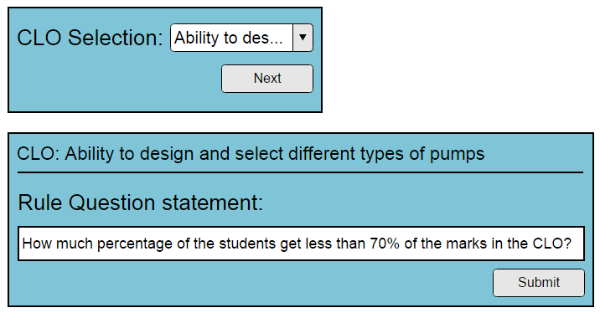

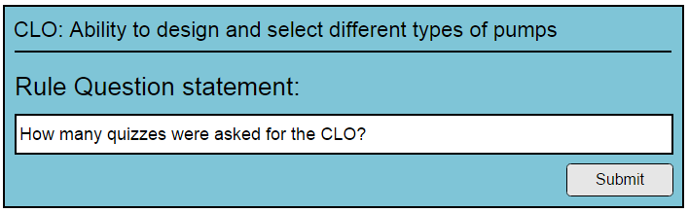

### Screen Fields

|  |  |  |
| --- | --- | --- |
| Field Name | Mandatory | Type |
| CLO | Yes | Drop Down Selection |
| Rule Question statement | Yes | String |

### Screen Actions:

|  |  |
| --- | --- |
| Action Name | Action to Perform |
| Submit | The use will be taken to the screen of rule question's answer. There the user may add answer's option for the question. |

## Add a rule question answer

This screen will be available to the experts, when they will create a rule question. The user will add rules question answers for the rules of expert system.

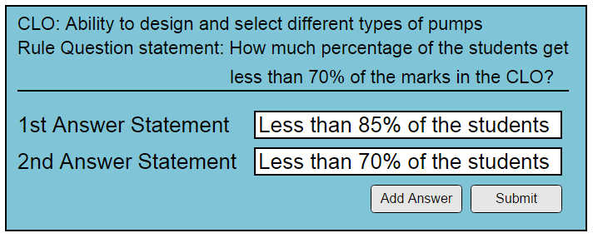

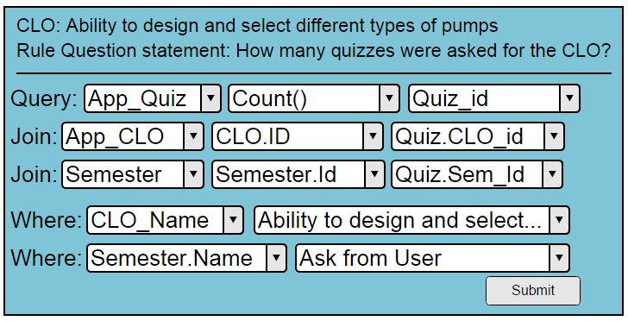

### Screen Fields

|  |  |  |
| --- | --- | --- |
| Field Name | Mandatory | Type |
| Rule Answer statement | Yes | String |

### Screen Actions:

|  |  |
| --- | --- |
| Action Name | Action to Perform |
| Add | Add a new rule answer, save the rule answer and show blank field to store one more rule answer |
| Submit | Add the rule question and answers in database |

## Use case - Add a rule

The user will first enter the rule statement; then the user will select the rule questions' answer. Each question along with its answer will be presented to the user.

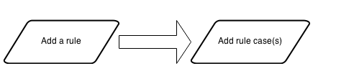

## Add a rule

This screen will be available to the expert. They may add a rule for improvement.

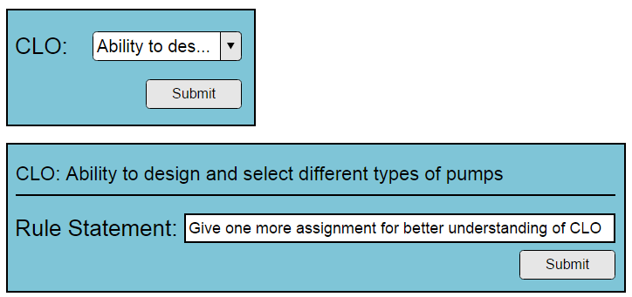

### Screen Fields

|  |  |  |
| --- | --- | --- |
| Field Name | Mandatory | Type |
| CLO | Yes | Drop Down Selection |
| Rule Statement | Yes | String |

### Screen Actions:

|  |  |
| --- | --- |
| Action Name | Action to Perform |
| Submit | Take the user to ask the attribute values for this question (screen: Add a rule case) |

## Add rule case(s)

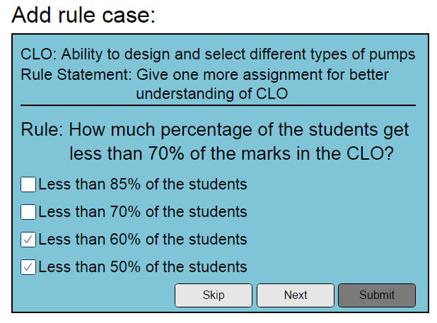

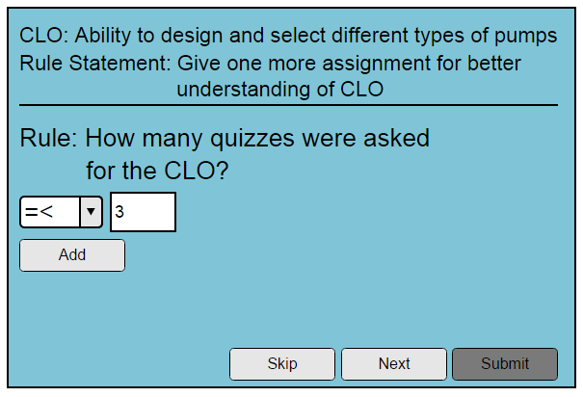

This screen will be available to the experts. When they will submit a rule, this screen will open, asking them to tell the rule cases. They may add rule cases for the new rule. One by one each rule question along with their answer will be presented to the user. He may skip the question or select answer(s).

### Screen Fields

|  |  |  |
| --- | --- | --- |
| Field Name | Mandatory | Type |
| Rule Question Statement | Yes | String |
| Rule Question Answer Section |  | Section |
| Answer Statement | No | Checkbox Selection (in list, showing all of the answers associated with the question) |

### Screen Actions:

|  |  |
| --- | --- |
| Action Name | Action to Perform |
| Skip | Clicking this button will not associate the current question with the rule and will show the next question (if any) for selection. If no more question exist, system will show a related message. |
| Submit | Add the rule along with the questions and their answers in database |

## Use case - Asking system for Improvement Suggestions

The user will select a CLO, then the system will show the all the rule questions and ask the user to select question's answer. When all the questions have been asked from the user, the system will perform inferencing on the basis of user input and then the system will show the suggestion for improvement in the selected CLO.

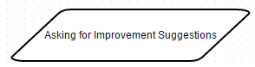

## Asking System for Improvement Suggestions

This screen will be available to the teachers/experts/moderator. They may ask the system for improvement suggestions. The rules along with their cases will be presented to the user, he may select that rule or skip it. The selected rule questions will become search criteria. All the rules which matches the search criteria will be shown to the user.

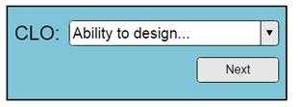

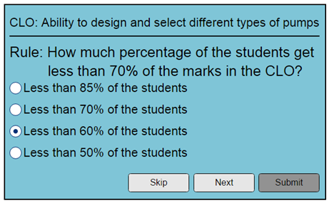

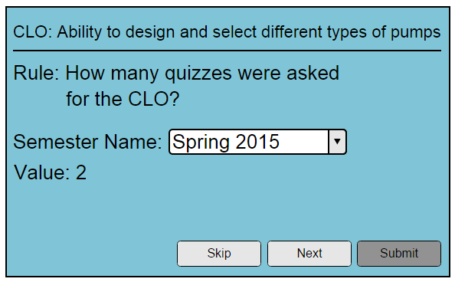

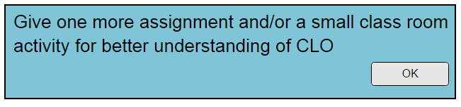

### Screen Fields

|  |  |  |
| --- | --- | --- |
| Field Name | Mandatory | Type |
| CLO | Yes | Drop Down Selection |
| Rule Question Statement | Yes | String |
| Rule Question's Answer Section |  | Section |
| Rule Question's Answer Statement | No | Radio Selection (in list, showing all of the answers options associated with the question) |

### Screen Actions:

|  |  |
| --- | --- |
| Action Name | Action to Perform |
| Skip | Clicking this button will not associate the current questions' answer with the search criteria and will show the next question (if any) for selection. If no more attribute exist, system will show a related message. |
| Submit | Suggest an improvement plan based on the processing done for the given search criteria. |

# Question Bank

## Use case - Add an attribute

In this use case the user will first add an attribute. Then user will add options associated with the added attribute.

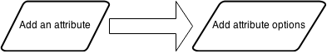

## Add an attribute

This screen will be available to the experts/moderator. They may add an attribute for the questions (in question bank)

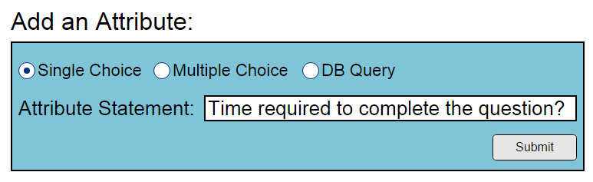

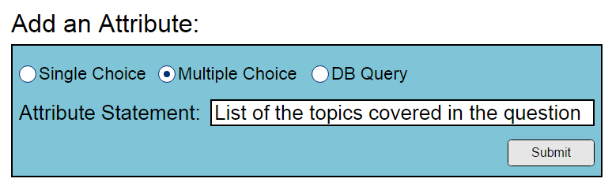

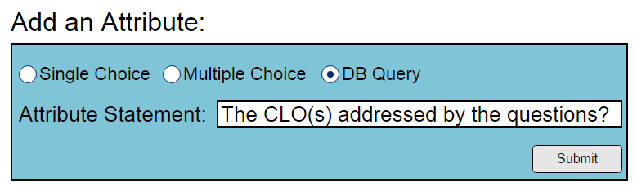

### Screen Fields

|  |  |  |
| --- | --- | --- |
| Field Name | Mandatory | Type |
| Attribute Statement | Yes | String |

### Screen Actions:

|  |  |
| --- | --- |
| Action Name | Action to Perform |
| Submit | Take the user to Attribute options screen |

## Add an attribute Options

This screen will be available to the experts/moderator. They may add an attribute option for the questions (in question bank)

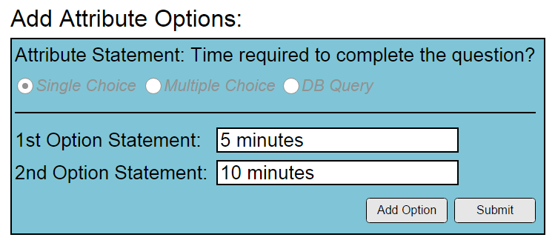

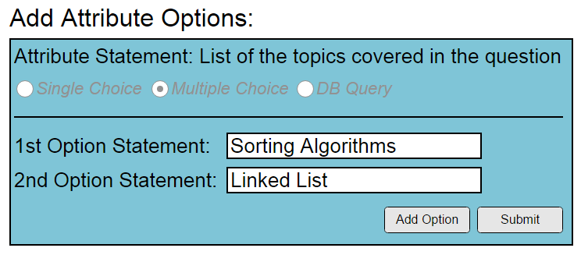

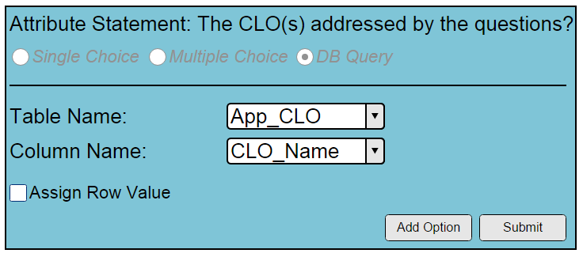

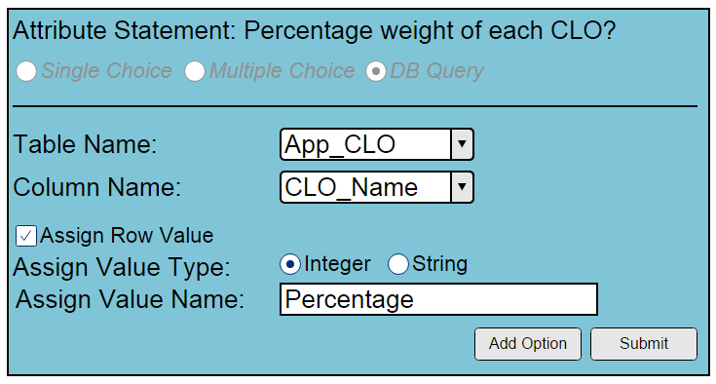

### Screen Fields

|  |  |  |
| --- | --- | --- |
| Field Name | Mandatory | Type |
| Attribute Option Statement | Yes | String |

### Screen Actions:

|  |  |
| --- | --- |
| Action Name | Action to Perform |
| Add | Add a new attribute option, save the attribute option and show blank field to store one more attribute option |
| Submit | Add the attribute and attribute options in database |

## Use case - Add a question

In this use case, first user will add a question, then the user will assign the attributes to the added question.

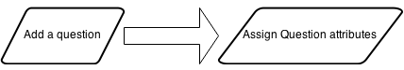

## Add a question

This screen will be available to the teachers/experts/moderator. They may add a question (in question bank)

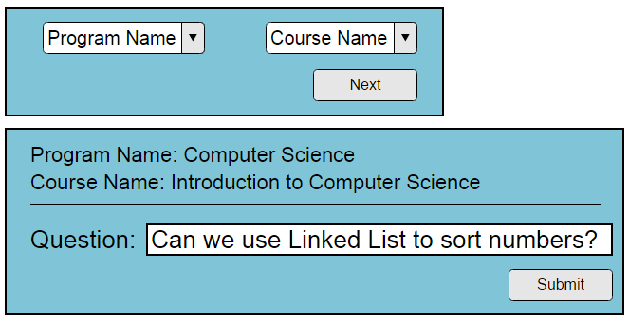

### Screen Fields

|  |  |  |
| --- | --- | --- |
| Field Name | Mandatory | Type |
| Program Name | Yes | Drop Down Selection |
| Course Name | Yes | Drop Down Selection |
| Question Statement | Yes | String |

### Screen Actions:

|  |  |
| --- | --- |
| Action Name | Action to Perform |
| Next | Take the user to ask the attribute values for this question (screen: Add a question attribute) |

## Assign question attribute(s)

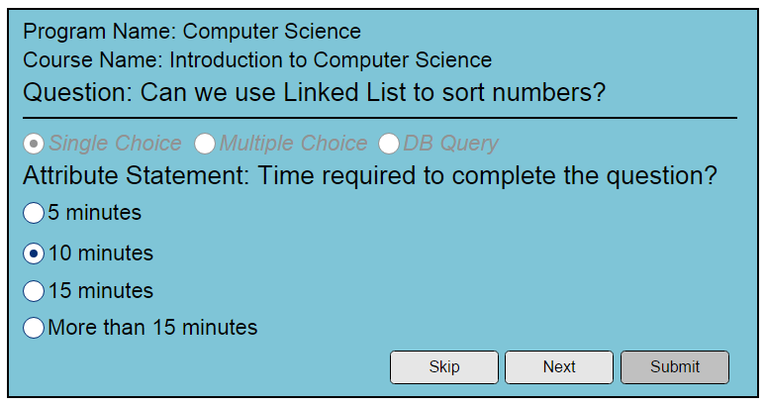

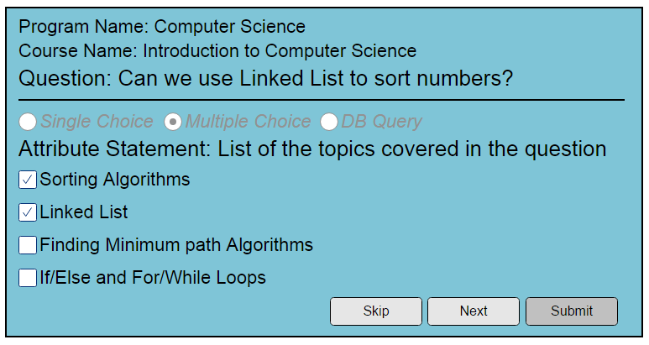

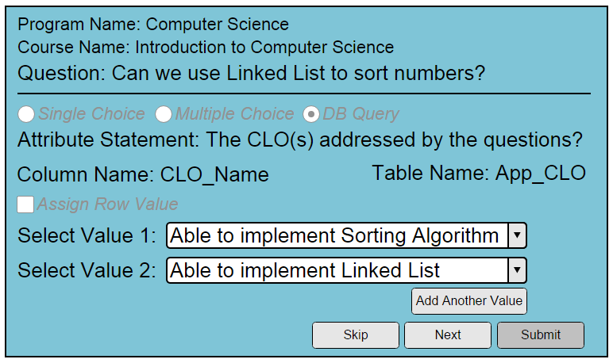

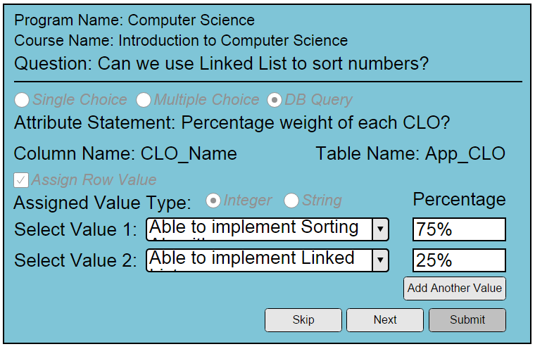

This screen will be available to the teachers/experts/moderator. When they will submit a question, this screen will open, asking them to tell the question attributes. They may add attributes for the question. One by one each attribute along with their attribute options will be presented to the user. He may skip the attribute or select attribute option(s).

### Screen Fields

|  |  |  |
| --- | --- | --- |
| Field Name | Mandatory | Type |
| Attribute Statement | Yes | String |
| Attribute Option Section |  | Section |
| Attribute Option Statement | No | Checkbox Selection (in list, showing all of the attribute options associated with the attribute) |

### Screen Actions:

|  |  |
| --- | --- |
| Action Name | Action to Perform |
| Skip | Clicking this button will not associate the current attribute with the question and will show the next attribute (if any) for selection. If no more attribute exist, system will show a related message. |
| Submit | Add the question along with the attributes in database |

## Use case - Add a favorite list

When a user will start creating a favorite list, the user will click on Add a Favorite List button from menu. Then the user will select the attribute options and then user will pick some/all question(s) from the questions suggested by Expert System.

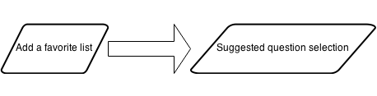

## Add a Favorite List

This screen will be available to the teachers/experts/moderator. They may create a custom list of questions to be used in any assessment method. The attributes of the question will be presented to the user, he may select that attribute or skip it. The selected attributes will become search criteria for the questions. All the questions which matches the search criteria will be shown to be selected by the user, the user will select the questions from suggested list of questions. And their selected questions will be saved in the form of favorite list. The user may see the favorite list later any time.

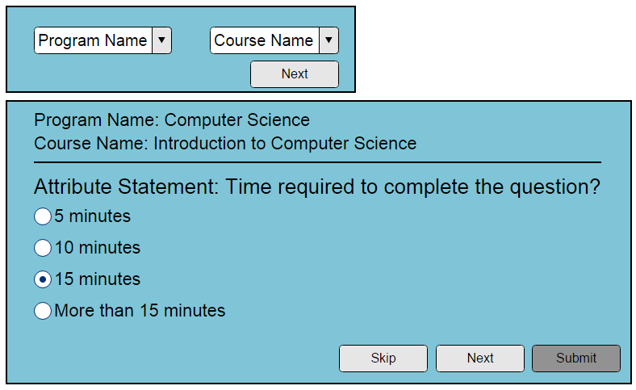

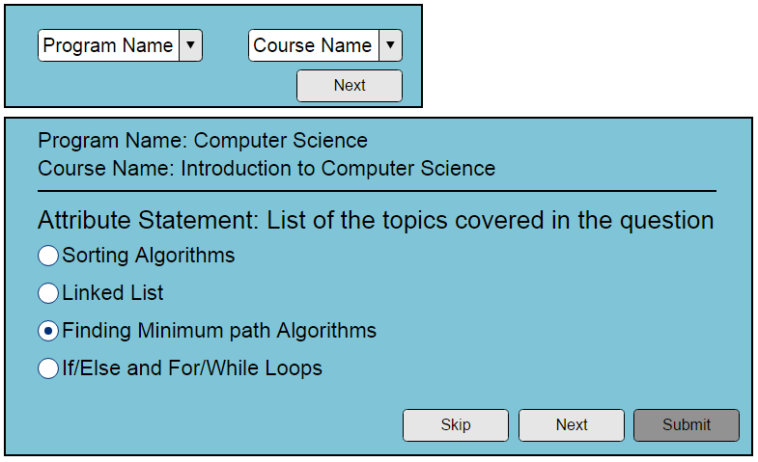

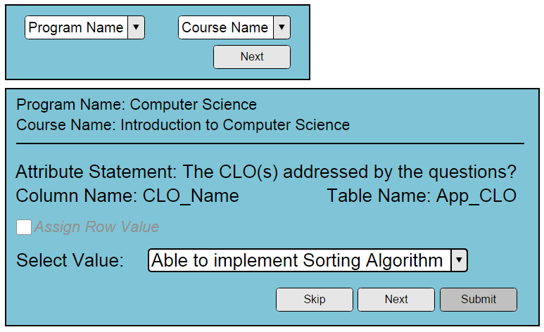

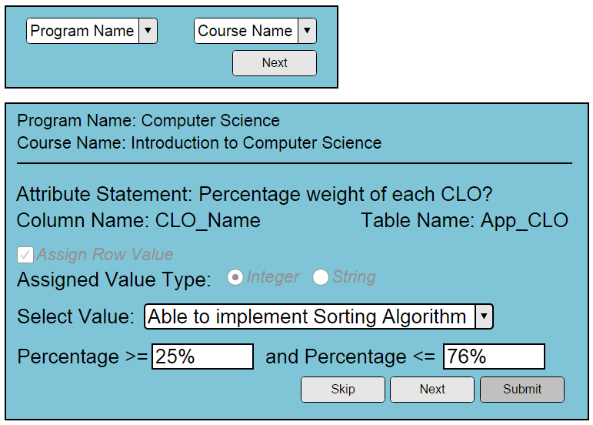

### Screen Fields

|  |  |  |
| --- | --- | --- |
| Field Name | Mandatory | Type |
| Program Name | Yes | Drop Down Selection |
| Course Name | Yes | Drop Down Selection |
| Attribute Statement | Yes | String |
| Attribute Option Section |  | Section |
| Attribute Option Statement | No | Radio Selection (in list, showing all of the attribute options associated with the attribute) |

### Screen Actions:

|  |  |
| --- | --- |
| Action Name | Action to Perform |
| Skip | Clicking this button will not associate the current attribute with the search criteria and will show the next attribute (if any) for selection. If no more attribute exist system will show a related message. |
| Submit | Show a list of suggested questions (described in screen name: suggested question for favorite list) |

## Suggested Questions Selection for Favorite List

This screen will be shown to the user after the user has selected and input the attribute options for the search criteria of a favorite list. The system will perform computation based on the search criteria and will show a list of the suggested questions. The user will have a check box along with each question to be selected.

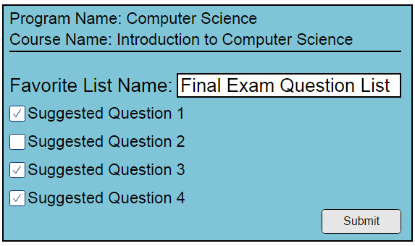

### Screen Fields

|  |  |  |
| --- | --- | --- |
| Field Name | Mandatory | Type |
| Favorite List Name | Yes | String |
| Question statement | Read-only | String |
| Selection Option | No | Checkbox |

### Screen Actions:

|  |  |
| --- | --- |
| Action Name | Action to Perform |
| Submit | The selected questions will be added to the favorite list and favorite list will be saved in the database for future use. |

# Data Dictionary

|  |  |  |  |  |
| --- | --- | --- | --- | --- |
| Table Name | Field Name | Data Type | Max Length | Is Nullable |
| App_Course | course_id | int | 4 | No |
| App_Course | App_Program_program_id | int | 4 | No |
| App_Course | course_name | varchar | 1 | Yes |
| App_Instructor | instructor_id | int | 4 | No |
| App_Instructor | instructor_name | varchar | 1 | Yes |
| App_Program | program_id | int | 4 | No |
| App_Program | program_name | varchar | 1 | Yes |
| I_CLO | clo_id | int | 4 | No |
| I_CLO | App_Course_course_id | int | 4 | No |
| I_CLO | clo_statement | varchar | 1 | Yes |
| I_Rule | rule_id | int | 4 | No |
| I_Rule | I_CLO_clo_id | int | 4 | No |
| I_Rule | rule_statement | varchar | 1 | Yes |
| I_Rule_Case | rule_case_id | int | 4 | No |
| I_Rule_Case | I_Rule_Ques_Answer_answer_id | int | 4 | No |
| I_Rule_Case | I_Rule_Question_rule_question_id | int | 4 | No |
| I_Rule_Case | I_Rule_rule_id | int | 4 | No |
| I_Rule_Ques_Answer | answer_id | int | 4 | No |
| I_Rule_Ques_Answer | I_Rule_Question_rule_question_id | int | 4 | No |
| I_Rule_Ques_Answer | answer_statement | varchar | 1 | Yes |
| I_Rule_Question | rule_question_id | int | 4 | No |
| I_Rule_Question | I_CLO_clo_id | int | 4 | No |
| I_Rule_Question | rule_ques_statement | varchar | 1 | Yes |
| Q_Attribute | attribute_id | int | 4 | No |
| Q_Attribute | attribute_statement | varchar | 1 | Yes |
| Q_Attribute | table_name | varchar | 1 | Yes |
| Q_Attribute | table_column_name | varchar | 1 | No |
| Q_Attribute_Options | attribute_option_id | int | 4 | No |
| Q_Attribute_Options | Q_Attribute_attribute_id | int | 4 | No |
| Q_Attribute_Options | option_statement | varchar | 1 | Yes |
| Q_Attribute_Options | table_row_id | int | 4 | Yes |
| Q_Attribute_Options | attached_value | varchar | 1 | Yes |
| Q_Favorite_List | favorite_list_id | int | 4 | No |
| Q_Favorite_List | App_Instructor_instructor_id | int | 4 | No |
| Q_Favorite_List | App_Program_program_id | int | 4 | No |
| Q_Favorite_List | App_Course_course_id | int | 4 | No |
| Q_Favorite_List_has_Q_Question | Q_Favorite_List_favorite_list_id | int | 4 | No |
| Q_Favorite_List_has_Q_Question | Q_Question_question_id | int | 4 | No |
| Q_Question | question_id | int | 4 | No |
| Q_Question | App_Instructor_instructor_id | int | 4 | No |
| Q_Question | App_Course_course_id | int | 4 | No |
| Q_Question | App_Program_program_id | int | 4 | No |
| Q_Question | question_statement | varchar | 1 | Yes |
| Q_Question | question_type | int | 4 | Yes |
| Q_Question_Attribute_Option | ques_att_option_id | int | 4 | No |
| Q_Question_Attribute_Option | Q_Attribute_Options_attribute_option_id | int | 4 | No |
| Q_Question_Attribute_Option | Q_Attribute_attribute_id | int | 4 | No |
| Q_Question_Attribute_Option | Q_Question_question_id | int | 4 | No |
| Q_Question_Attribute_Option | table_row_id | int | 4 | Yes |

# Database schema:

